Education and Outreach

Blue CREST Award

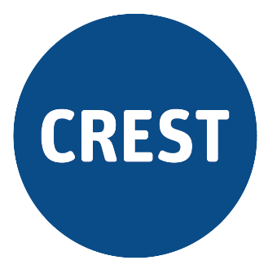
Science Investigation: Tides – Student Guidance
You've probably noticed the rise and fall of the water in the local creeks and the river, and when you've visited the beach. If you've ever been fishing, or surfing, you'll have looked up the timing and height of the tides to choose the right times to go out. But you might not have thought much about what causes these tides, or how we predict them.

Learning Activities

1. Record your ideas about the tides in a TWLH Chart.
- What do you THINK you know about the tides?
- What do you WANT to know about the tides?
The Bureau of Meteorology (BoM) publishes data on the heights of tides at different locations around Australia where this data might be useful. You can find it here [http://www.bom.gov.au/australia/tides/].

2. Load up the data for your local area and explore it.
Here are some questions to stimulate your thinking.
- What do you notice about this data?
- How were the data obtained?
- What types of data are included? Why?
- What are the limits of the data?
- Can you see any patterns in the data?
- Is this data linked to other phenomena?
- How can this data be analysed and interpreted?
Download and view the data for the whole year using the link provided on the BoM website.

3. Make sense of the data.
Scientific knowledge often (but not always) arises from the careful collection, organisation, analysis, and interpretation of quantitative data, which we use as evidence for our arguments, explanations, and for making predictions about what will happen in the future.
Data can be organised in different ways that help us to make sense of it and generate explanations.
- How could you organise this data?
- How could you graph this data?
You can use paper and pen, Excel, Sheets or some other graphing software that you have access to.

4. Add to your TWLH Chart.
- What have you LEARNED about the tides?
- HOW have you developed your understanding?

5. Now that you’ve explored this data, try to find a question to investigate.
Your teacher will help guide you through this. You may do this individually or in a group.

6. Use the Intermediate CREST Awards Investigation Planner to plan and carry out an investigation.
Ensure that you record all details of your planning, results and evaluation.
Explain your data using scientific ideas and reasoning. Your teacher can help you to do this.

7. Communicate your findings to your peers and/or teacher.
You might write a report, or perhaps you’d like to give an oral presentation, prepare and present a poster, record a short video, or use some other appropriate medium or format to communicate your findings. Talk to your teacher to negotiate the means of communication.

8. Complete the Blue CREST Awards Checklist with your teacher.
Don’t forget to complete the summary on the last page!

