Education and Outreach

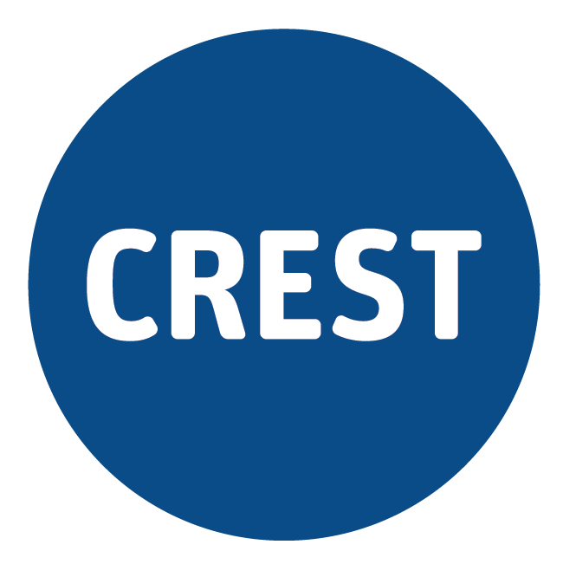Blue CREST Award

Science Investigation: Tides – Teacher Guidance
In this inquiry, students will explore data related to the height and timing of the tides in their local waterways and organise and graph this data. This will stimulate students to generate questions that they can investigate using this data, other sources of data, or by generating new data scientifically. Students will plan and carry out their investigation using the Intermediate CREST Awards Investigation Planner. Finally, students will communicate their findings, and complete the Blue CREST Awards Checklist.
We recommend that you, as their teacher:
- Provide age-appropriate resources, both online and offline, to help students to gain an understanding of the tides, their causes, and the data
- Facilitate students to generate questions using the strategies outlined in the CREST Snapshot: Finding questions
- Guide students to use the Intermediate CREST Awards Investigation Planner and check that their plans are appropriate before allowing them to collect or organise data
- Monitor students’ investigations using the Blue CREST Awards Checklist, giving feedback as necessary
- Scaffold students to generate explanations using the framework outlined in the CREST Snapshot: Constructing explanations
- Submit Award details on CREST Online to order certificates that recognise your students’ efforts. Medallions are also available for Blue CREST Award recipients, at a cost of $4 each.

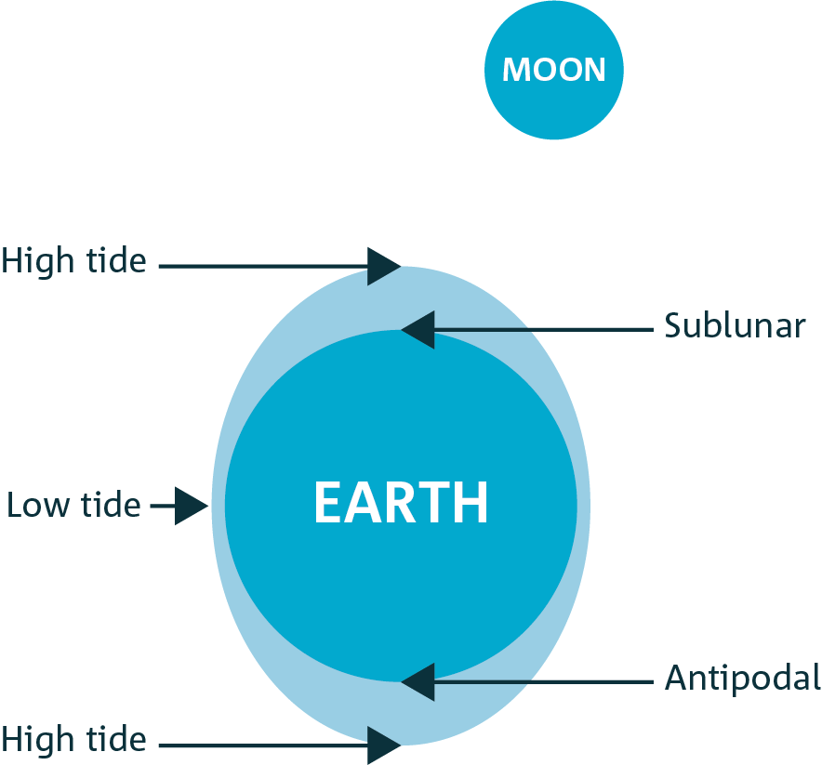Teacher Background Information
Forces are interactions between bodies. Forces are directional. Gravity describes the force of attraction between bodies. The greater the mass of each body, and the smaller the distance between them, the greater the size of the gravitational attraction. The dynamic system of movements of Earth, Moon and Sun are maintained by the forces of gravity between them, and other bodies in the solar system and universe.
The gravitational attraction between Earth and the Moon, and Earth and the Sun, causes the fluid material on
Earth – including the crust and the water – to move toward the Moon and the Sun. The motion of the water due to these gravitational forces are called tides.
Figure 1: The Moon draws the water on Earth toward it
There is a misconception that the tides are due only to the gravitational force between Earth and the Moon. The Sun also influences the tides. Even though it is much further away from Earth than the Moon, the Sun is also much larger. The Moon exerts the greater influence of the two bodies.
The force of gravity between the Moon and Earth is stronger at the point on Earth that is closest to the Moon than the point on Earth that is furthest away. This causes a bulge – a high tide – on both sides of Earth (Figure 1: The Moon draws the water on Earth toward it).
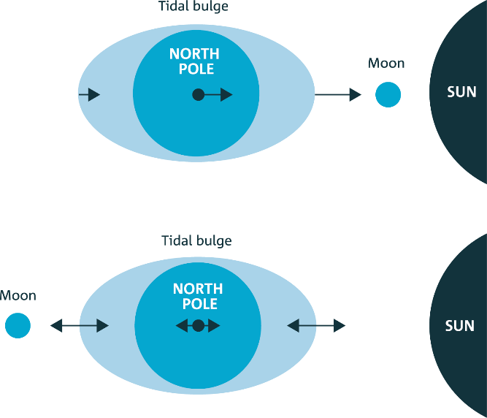
When the three bodies are not aligned, and especially when they are at right-angles to each other, the tides are moderate, with a small difference between the high and the low tide. When the three bodies are aligned, these tides change dramatically, and are very high or very low at different places on Earth, particularly in locations close to the Equator
(Figure 2: King tides occur when the Sun, Earth, and Moon are aligned). A very high tide due to the alignment of Earth, Moon and Sun is colloquially known as a king tide, while neap tides are those with minimal variation.
Figure 2: King tides occur when the Sun, Earth, and Moon are aligned
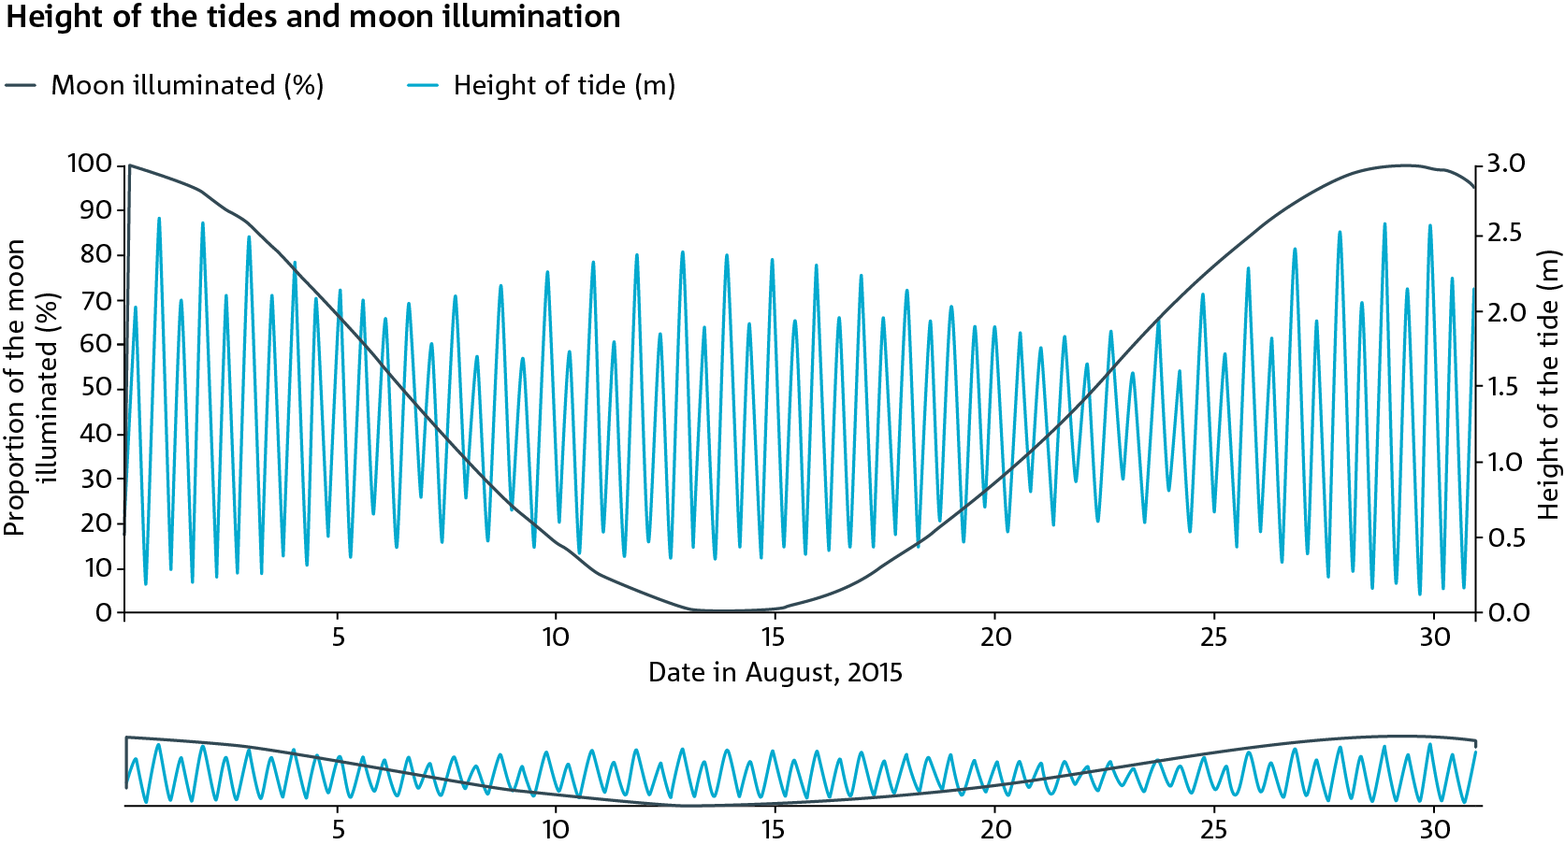
Figure 3: There is a relationship between the phase of the Moon and the height of the tides
Earth, Moon and Sun are not often aligned. The Moon takes nearly 28 days to orbit Earth, and Earth spins about 29.5 times beneath it as it orbits. At the same time, Earth orbits the Sun. During the periods of a Full Moon and a New Moon, the tides are at their most extreme. Figure 3 shows the relationship between the phase of the Moon and the height of the tides.
However, the Moon's plane of orbit about Earth is tilted by about 5 degrees, so perfect alignment between the three bodies is very rare (and is also the cause of either a full or partial solar or lunar eclipse).

Australian Curriculum Outcomes

Prior knowledge and skills
- Year 3 Science Understanding Earth and Space ACSSU048: Earth’s rotation on its axis causes regular changes, including night and day
- Year 4 Science Understanding Physics ACSSU076: Forces can be exerted by one object on another through direct contact or from a distance
- Year 5 Science Understanding Earth and Space ACSSU078: The Earth is part of a system of planets orbiting around a star (the sun)

Science Understanding (Year 7)
- Earth and Space ACSSU115: Predictable phenomena on Earth, including seasons and eclipses, are caused by the relative positions of the sun, Earth and the moon

Science as Human Endeavour (Years 7 & 8)
- Nature and Development of Science ACSHE119/134: Scientific knowledge has changed peoples’ understanding of the world and is refined as new evidence becomes available

Science Inquiry Skills (Years 7 & 8)
- Questioning and predicting ACSIS124/139: Identify questions and problems that can be investigated scientifically and make predictions based on scientific knowledge
- Planning and conducting ACSIS125/140: Collaboratively and individually plan and conduct a range of investigation types, including fieldwork and experiments, ensuring safety and ethical guidelines are followed
- Planning and conducting ACSIS126/141: Measure and control variables, select equipment appropriate to the task and collect data with accuracy
- Processing and analysing data and information ACSIS129/144: Construct and use a range of representations, including graphs, keys and models to represent and analyse patterns or relationships in data using digital technologies as appropriate
- Processing and analysing data and information ACSIS130/145: Summarise data, from students’ own investigations and secondary sources, and use scientific understanding to identify relationships and draw conclusions based on evidence
- Evaluating ACSIS131/146: Reflect on scientific investigations including evaluating the quality of the data collected, and identifying improvements
- Evaluating ACSIS132/234: Use scientific knowledge and findings from investigations to evaluate claims based on evidence
- Communicating ACSIS133/148: Communicate ideas, findings and evidence based solutions to problems using scientific language, and representations, using digital technologies as appropriate

General capabilities
- Critical and Creative Thinking: In this activity, students will pose questions and organise and process information about the causes and impacts of the tides. They will apply logic and reasoning and evaluate data in the generation of an explanation.
- Personal and Social Capability: This activity presents an opportunity for students to practice, develop and apply their capabilities to work independently and show initiative (either individually, or as a small group), to become confident, resilient, and adaptable in their interactions with others, and to communicate effectively and work collaboratively as they complete their inquiry.
- Literacy: During this investigation, students may comprehend texts, and compose texts, applying their understanding of scientific vocabulary, in order to explain their understandings.

Did you find this resource useful?
We appreciate your feedback. Please email the team at crest@csiro.au to tell us how this resource supported your teaching or your students’ learning, or how it can be improved. Thank you!

