Education and Outreach

Green CREST Award

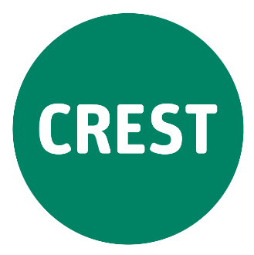
Science Investigation: How does the Moon’s appearance change? – Teacher Guidance
In this three-part science inquiry, students will engage with and explore concepts related to the phases of the Moon. They will make multiple observations of the appearance and position of the Moon over the course of approximately a month and share their observations with others working in a collaborative team. Students will then develop an explanation for their observations, generating a hypothesis regarding the relationship between the appearance and position of the moon as they relate to the phases of the Moon as viewed from Earth. Finally, students will evaluate their inquiry and suggest improvements.
Carefully scaffolded, this activity will motivate students, and engage them in critical and creative thinking. Working collaboratively with their peers, students will identify patterns of changes to the observable appearance and position of the Moon. Students will evaluate their inquiry skills and capabilities and reflect on their collaboration skills.

Australian Curriculum Alignment
This inquiry presents opportunities for students to develop, practise, and apply a number of understandings, skills, and capabilities from across the Australian Curriculum. A suggested list of Science content descriptions and General Capabilities appears at the end of this document.

Teacher Background Information
Earth’s Moon cycles through the phases over a period of approximately 29.5 days (as observed from Earth). This is the time it takes for the Moon to orbit Earth just once. This seems counterintuitive, as we observe the Moon pass across the sky each 25 hours or so. However, this observation is explained by the spin of Earth underneath the Moon, rather than the orbit of the Moon around Earth. Over the 29 days of the Moon’s orbit, the appearance and position of the Moon cycle through eight phases. Each day, the moon rises on the eastern horizon and sets in the western sky about 45-50 minutes later than the day before.
The cycle begins with a New Moon. The New Moon rises at approximately 6 am and sets at approximately 6 pm. The New Moon is not visible from Earth as the light from the Sun is reflected (almost) completely away from Earth. As the Moon moves through its orbit, we view a crescent of the Moon that appears to grow. We say that it is waxing. We can observe a waxing crescent setting in the early evening.
The waxing crescent appears until the end of the First Quarter, at which time the Moon appears as a semi-circle, which we call a half moon. The First Quarter half moon rises at approximately midday and sets at approximately midnight; we can observe it setting in the late evening. In the southern hemisphere, we see what appears to be the left side of the Moon’s face; in the northern hemisphere, they see the exact same part of the Moon’s surface but it appears to be the right side of the Moon’s face. That is because each of the hemispheres views the Moon upside down relative to the other hemisphere. The half moon continues waxing but becomes gibbous; the part of the Moon that we cannot see is crescent-shaped.
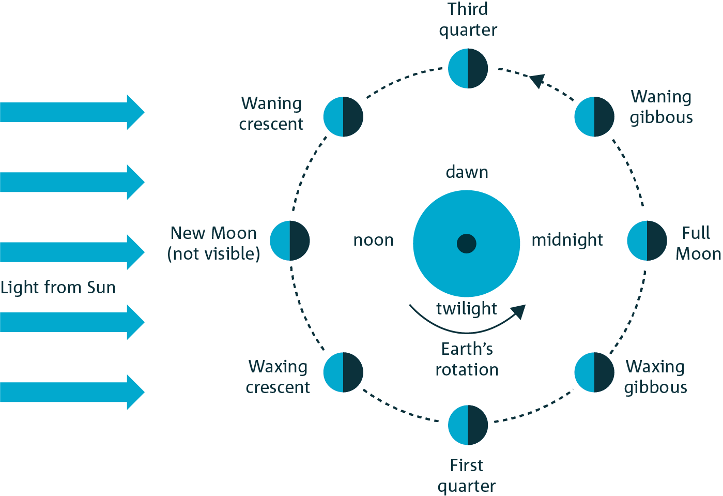
The waxing gibbous moon appears to gain size each day until it becomes a Full Moon, which reflects light from (almost) the entire side that is facing us here on Earth. The Full Moon rises at approximately 6 pm and sets at approximately 6 am. We can observe it rising in the early evening and setting early in the morning.
Following a Full Moon, in the Third Quarter, we observe the Moon appear to shrink each night. It doesn’t really shrink, but the fraction illuminated decreases each night. We say that it is waning. It continues to rise and set later than it did the day before. We can observe a waning gibbous moon rise late at night and set the following morning. In the southern hemisphere, we see what appears to be the right side of the Moon’s face; in the northern hemisphere, they see the exact same part of the Moon’s surface but it appears to be the left side of the Moon’s face. That is because each of the hemispheres views the Moon upside down relative to the other hemisphere.
The waning gibbous moon appears until the end of the Third Quarter, at which time the Moon appears once more as a half moon. The Third Quarter half moon rises at approximately midnight and sets at approximately midday; we can observe it setting in the early morning. The half moon continues waning and becomes a crescent.
The waning crescent continues to appear to shrink each day until we can no longer see it; it is a New Moon once more and the cycle begins anew.

Teaching and Learning Activities, Part 1 – Preparing to investigate

Engage and Explore
- Engage students in thinking about the Moon by asking them to draw or discuss the Moon’s appearance in small groups. Ask students when and in which direction they expect to see it, and what shape it appears to have. Ask them if anyone has seen it recently. Allow students to respectfully disagree with each other about the appearance, position, and other aspects of the Moon’s appearance. Ask the class why they think there is such disagreement about this, and how they might find a consensus on when, where, and how the Moon appears.
If there is no, or little, disagreement, ask them what data they could collect to confirm (or disconfirm) their consensus. Lead a dialogue with students to design an investigation to collect this data; guide them to the design used in this inquiry (described below and in the Student Guidance). Skip to step 7 of this learning sequence, and once students have started collecting their data, come back and guide students through the Explore and Explain activities detailed below.
- Introduce the inquiry question. Facilitate small group discussions about what they believe causes the moon to appear differently at different times. Encourage students to record their ideas and questions in their science journals or notebooks.
- In dialogue with the class, collate and share different ideas and any questions about the appearance of the Moon.
- Divide the class into small groups and assign each group one concept, or one of the questions that was generated by students, to describe, explore, and prepare to communicate. Relevant concepts include, but are not limited to:

- Orbit
- Spin
- Phases
- Full Moon
- New Moon
- Half moon
- Crescent
- Gibbous moon
Students can undertake some research using appropriate resources, online or offline. You might invite students to prepare a creative presentation to explain the concept to their class. For example, they may choose to present a dramatization, interpretive dance, graphic representation, diagram, series of photographs, poem or song, or model. Alternatively, asking each group to briefly describe or explain their focus concept will suffice.

Explain
- In groups, students should present their descriptions of their focus concepts to the class. Encourage students to keep a record of these ideas in their science journal.
Some scientific ideas that may arise from the explanations include:
- The Moon reflects the Sun’s light and does not emit its own light
- The Moon orbits Earth
- The Moon can be seen at different times of the day and night depending on which phase it is in
Some non-scientific ideas that may arise include:
- The Moon creates its own light
- The Moon can only be seen at night time
- The Moon’s phases are caused by Earth’s shadow falling upon the Moon (this would be a lunar eclipse), or by clouds passing over the Moon or between Earth and the Moon
- The Moon’s phases are caused by either Earth’s or the Moon’s rotation (spin) on its axis
- The Moon orbits the Sun
- The Moon orbits Earth once each day
There is no need to address each of these non-scientific ideas at this stage. Some will be addressed over the course of the inquiry. Others may need to be addressed by the teacher and explicitly discussed as students make sense of their observations over the course of the month.

Teaching and Learning Activities, Part 2 - Investigating

Elaborate
- Introduce the inquiry question. Lead a dialogue with students to design an investigation to collect data that would help them to develop a response to the question; guide them to develop a design like that used in this inquiry (described below and in the Student Guidance). Include discussion of risks and ethics of data collection.
- Distribute the Student Guidance to students and invite them to form groups of 3 or 4 students (or assign them to groups). Explicitly state your expectations of students during the investigation.
- Guide students to prepare their astrolabes. A template for the body of the astrolabe is at the end of this document (Appendix A). Photocopy the template on to cardboard. Each student will need one template.
- Give groups time to discuss how and when they will make their observations and record their data. Encourage students to take at least one observation each 24-hour period but let them know that missing one or two a week is understandable. As often as possible, each group should try to collect at least one observation per 24-hour period.
The investigation may stimulate students to ask other related questions. Value students’ questions by recording them on post-it notes somewhere visible in the classroom (writing students’ initials or names on the back will help you to determine the authors of the questions later). Questions that can be investigated empirically may be suitable for students interested in achieving an Orange or Blue CREST Award.
- Monitor students’ data collection over the course of the month. You can demonstrate that the data is both valued and valuable by calling on students to share their recent observations each time you teach a science lesson. You can also use the observation template included in this document (Appendix B) to record a class set of data to display in the classroom.
- You might like to encourage students to record any of their questions, ideas, frustrations, and thoughts about this activity in their science journal or notebook. This will help them to complete an evaluation in the next part of this investigation.
- Following the conclusion of their data collection, provide groups with time to collate their observations. Each group should explore their data, looking for patterns in the appearance and position of the Moon (time, angle, and direction).
- Facilitate students to explain their findings. The CREST Snapshot: Constructing explanations outlines the Claim – Evidence – Reasoning framework, which may be a useful scaffold for students in developing their explanations.

Teaching and Learning Activities, Part 3 - Evaluating the investigation

Evaluate
- Guide students to complete both written and verbal evaluation of their investigation and their learning about the relationship between changes in the Moon’s appearance and the phases of the Moon. Suggested discussion questions include:
- What were the challenges in completing this investigation?
- How could this investigation be improved?
- What advice would you give other students starting the investigation?
- What questions do you still have about the phases of the Moon?
- What have you learned from this investigation?
- Present each student who has met the Consolidating standard in the Introductory CREST Science Evaluation Rubric with their Green CREST Award. Please visit CREST Online to provide the details of the Awards, order stickers for the certificates and download the Green CREST Award Certificate for distribution to students. Consider whether your students are ready to move on to the Orange CREST Award. Encourage students to submit their investigation to your local Science Teachers’ Association Awards.

Resources for Students
Some useful online resources are listed below for use after students complete their observations/explanations:
- Source 1: Mapping the Moon (Double Helix activity examining the features of the Moon)
- Source 2: Moon phases (9-minute video from Academy of Science about what causes the phases of the moon)
- Source 3: At the planetarium: Phases of the Moon (Short video from ABC Education with animations of the moon phases)
- Source 4: Beginners guide to the Moon (Article from ABC Science News explaining phases, eclipses and supermoons)
- Source 5: Is the supermoon really super? (Quick video explanation from ABC Education of the ‘supermoon’ phenomena)

Australian Curriculum Outcomes

Prior knowledge and skills
- Year 3 Science Understanding Earth and Space ACSSU048: Earth’s rotation on its axis causes regular changes, including night and day
- Year 5 Science Understanding Earth and Space ACSSU078: The Earth is part of a system of planets orbiting around a star (the sun)

Science Understandings (Year 7)
- Earth and Space ACSSU115: Predictable phenomena on Earth, including seasons and eclipses, are caused by the relative positions of the sun, Earth and the moon

Science as a Human Endeavour (Years 7 & 8)
- Science as a Human Endeavour ACSHE119/134: Scientific knowledge has changed peoples’ understanding of the world and is refined as new evidence becomes available

Science Inquiry Skills (Years 7 & 8)
- Questioning and predicting ACSIS124/139: Identify questions and problems that can be investigated scientifically and make predictions based on scientific knowledge
- Planning and conducting ACSIS125/140: Collaboratively and individually plan and conduct a range of investigation types, including fieldwork and experiments, ensuring safety and ethical guidelines are followed
- Planning and conducting ACSIS126/141: Measure and control variables, select equipment appropriate to the task and collect data with accuracy
- Processing and analysing data and information ACSIS129/144: Construct and use a range of representations, including graphs, keys and models to represent and analyse patterns or relationships in data using digital technologies as appropriate
- Processing and analysing data and information ACSIS130/145: Summarise data, from students’ own investigations and secondary sources, and use scientific understanding to identify relationships and draw conclusions based on evidence
- Evaluating ACSIS131/146: Reflect on scientific investigations including evaluating the quality of the data collected, and identifying improvements
- Evaluating ACSIS132/234: Use scientific knowledge and findings from investigations to evaluate claims based on evidence
- Communicating ACSIS133/148: Communicate ideas, findings and evidence-based solutions to problems using scientific language, and representations, using digital technologies as appropriate
General capabilities
- Critical and Creative Thinking: In this activity, students will pose questions and organise and process information about changes to the appearance of the Moon. They will apply logic and reasoning and evaluate data in the generation of predictions based on patterns observed.
- Personal and Social Capability: This activity presents an opportunity for students to practice, develop and apply their capabilities to work independently and show initiative, to become confident, resilient, and adaptable, and to communicate effectively and work collaboratively as they complete the inquiry.
- Literacy: During this investigation, students will comprehend texts, and compose texts, applying their understanding of scientific vocabulary in order to explain their understandings.

Did you find this resource useful?
We appreciate your feedback. Please email the team at crest@csiro.au to tell us how this resource supported your teaching or your students’ learning, or how it can be improved. Thank you!

Appendix A: Astrolabe templates
Photocopy this page on to card.

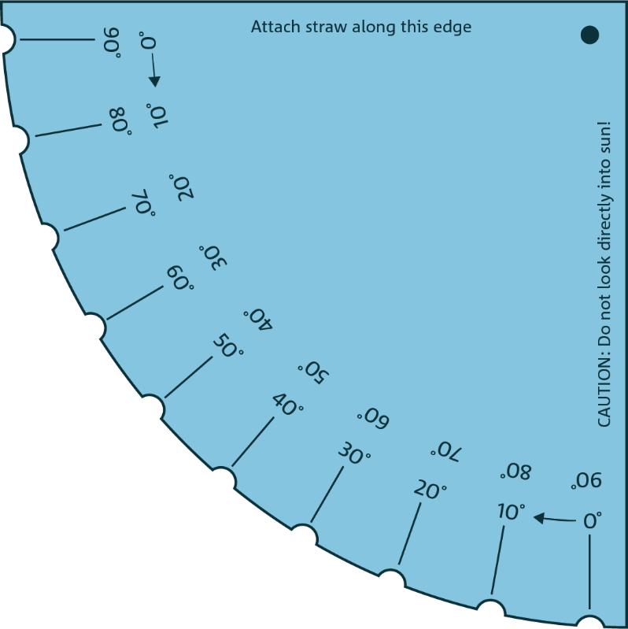
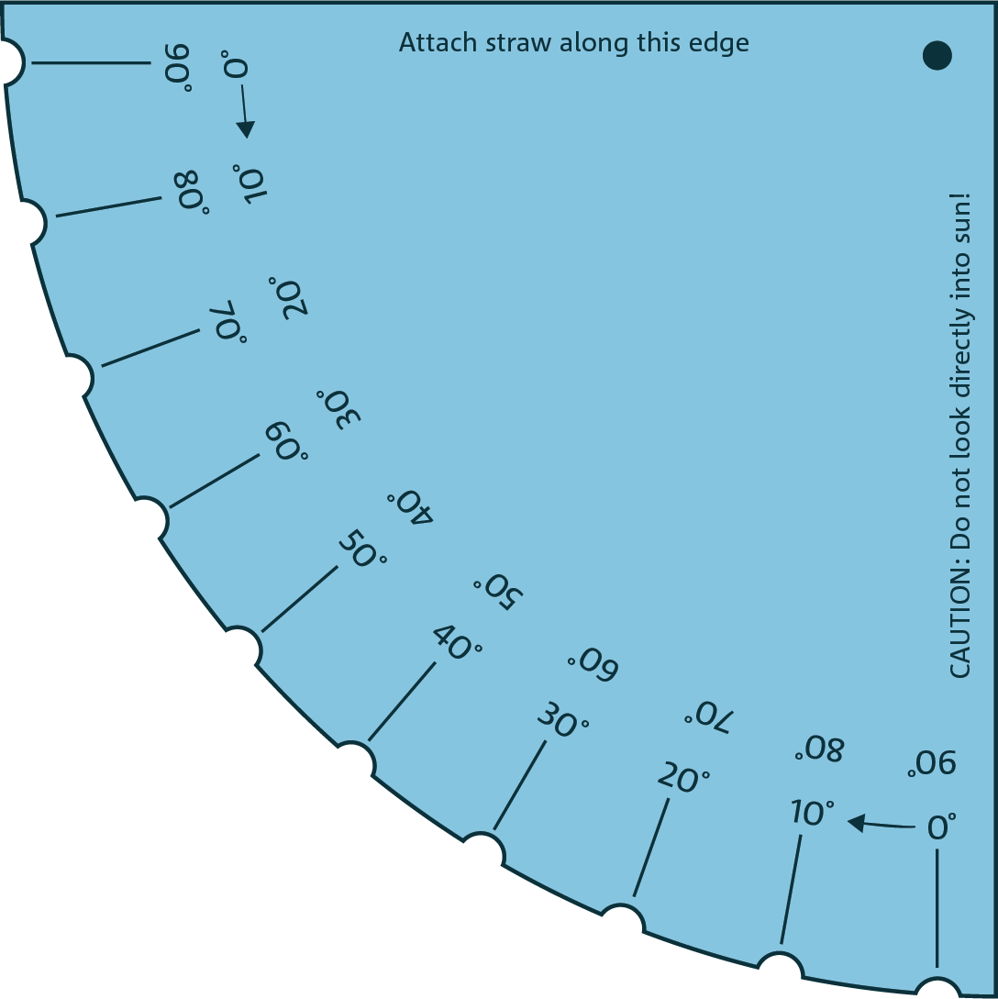

Appendix B: Observation record
Photocopy this page. Collate students’ observations in a classroom display.

Date:
Time:
Angle:
Direction:

